**Ideation Phase**

**Brainstorm & Idea Prioritization Template**

|  |  |
| --- | --- |
| Date | 01 NOV 2025 |
| Team ID | NM2025TMID02455 |
| Project Name | Medical Inventory Management |
| Maximum Marks | 4 Marks |

Medical Inventory Management **Template** :

This guided project focuses on building a **Medical Inventory Management System** in Salesforce to streamline the tracking and management of medical supplies. It includes creating custom objects for products, suppliers, and purchase orders, along with fields to monitor stock levels, batch details, and expiry dates. Validation rules and relationships ensure accurate data entry and consistency across the system.

Automation is achieved through **Flows and Triggers** that update stock levels and send alerts for expiring products. Reports and dashboards offer real-time insights into inventory performance and supplier efficiency. Overall, this system helps healthcare organizations reduce wastage, prevent stockouts, and maintain accurate, efficient inventory control.

**Step-1: Team Gathering, Collaboration and Select the Problem Statement:**

**Step-2: Brainstorm, Idea Listing and Grouping:**

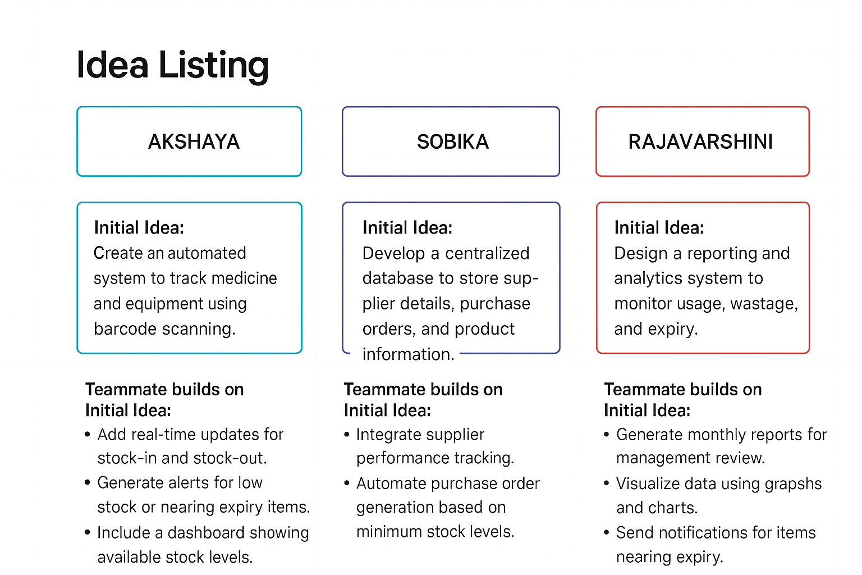

Fig2: Image that describes the work done by teammates.

* **Brainstorm:**

Team shares ideas to improve inventory tracking, procurement, and expiry management.

* **Idea Listing:**

All suggestions are recorded to ensure every input—from software features to audit procedures—is captured.

* **Grouping:**

Ideas are organized into categories like stock monitoring, procurement, expiration management, and reporting to identify patterns and prioritize actions.

* **Action Planning:**

Selected ideas are turned into concrete steps with assigned responsibilities, timelines, and monitoring to ensure effective implementation.

**Step-3: Idea Prioritization:**

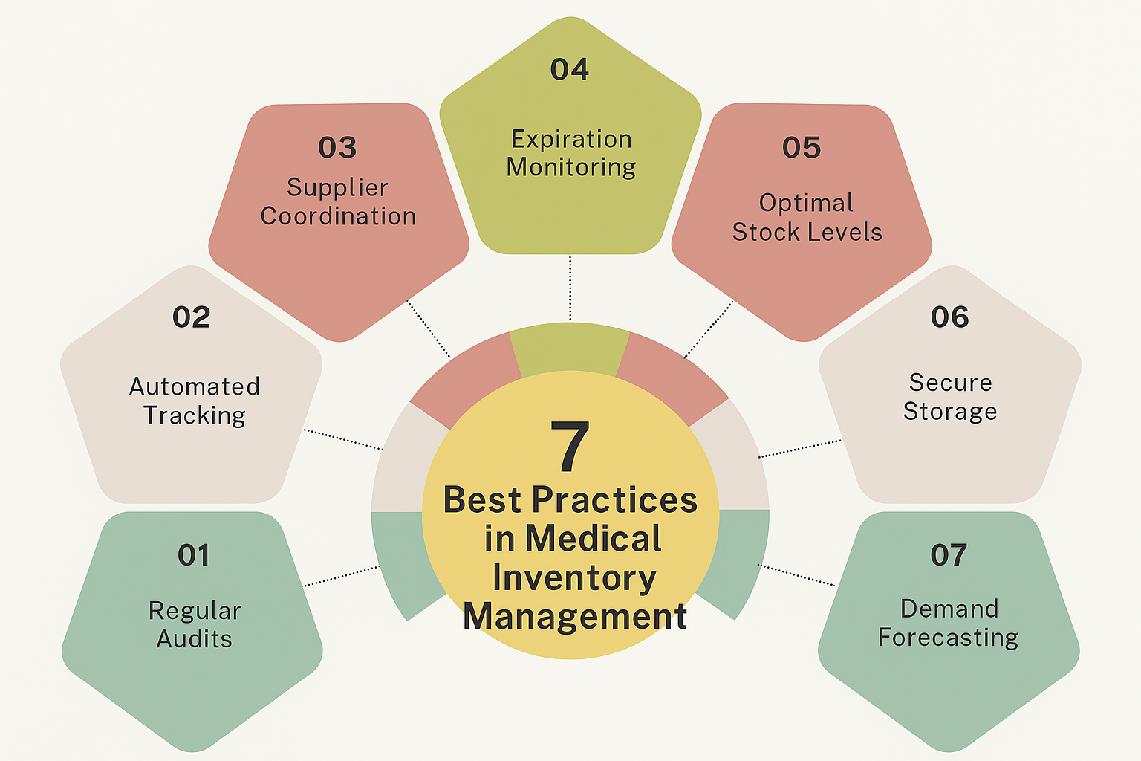

Fig3: Image of steps is the best practices in medical inventory management.

**Idea Prioritization:**

Idea prioritization helps focus on the most impactful improvements in medical inventory management. The primary goal is to ensure essential medicines and supplies are available, with accurate tracking of stock levels and expiry dates. Critical tasks like automated stock alerts, expiry monitoring, and access control are addressed first, followed by high-priority tasks such as automated reordering, supplier management, and reporting dashboards. Medium- and low-priority enhancements like barcode scanning, audit trails, and predictive analytics can be implemented gradually. This approach clarifies urgent actions, improves inventory security, and supports smooth, efficient execution.